Proto Root

What is Proto Root
# Source: Chatgpt (GPT-4-turbo) at [7/29/2025]
A proto root (also called a primitive root or etymological root) refers to the earliest known form of a word root from which other related words in various languages have evolved. These roots are often reconstructed by linguists and are not used as standalone words in modern languages.

🔹 Definition of Proto Root:
# Source: Chatgpt (GPT-4-turbo) at [7/29/2025]
A proto root is the original root morpheme (often reconstructed and marked with an asterisk, e.g., *ped-), typically traced back to a proto-language like Proto-Indo-European (PIE), the hypothetical ancestor of many modern languages in Europe and parts of Asia.

🔹 Examples of Proto Roots:
# Source: Chatgpt (GPT-4-turbo) at [7/29/2025]
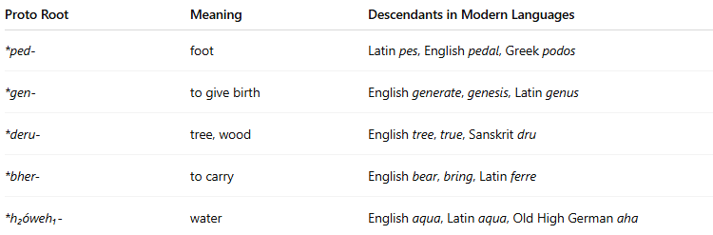
Proto Root | Meaning | Descendants in Modern Languages
*ped- | foot | Latin pes, English pedal, Greek podos
*gen- | to give birth | English generate, genesis, Latin genus
*deru- | tree, wood | English tree, true, Sanskrit dru
*bher- | to carry | English bear, bring, Latin ferre
*h₂óweh₁- | water | English aqua, Latin aqua, Old High German aha
🔸 The asterisk (*) indicates a reconstructed form—not directly attested in written records, but inferred by comparing related words across languages.

🔹 Features of Proto Roots:
# Source: Chatgpt (GPT-4-turbo) at [7/29/2025]
- ❌ Not used as words in modern languages.
- ✅ Serve as the origin of many related words across language families.
- ✅ Reconstructed by historical linguists through comparative methods.
- ✅ Often come from proto-languages like Proto-Indo-European (PIE).
- ✅ Provide insight into the etymology and evolution of language.

🔹 Proto Root vs. Free/Bound Root:
# Source: Chatgpt (GPT-4-turbo) at [7/29/2025]
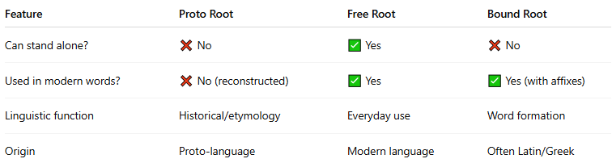
Feature | Proto Root | Free Root | Bound Root
Can stand alone? | ❌ No | ✅ Yes | ❌ No
Used in modern words? | ❌ No (reconstructed) | ✅ Yes | ✅ Yes (with affixes)
Linguistic function | Historical/etymology | Everyday use | Word formation
Origin | Proto-language | Modern language | Often Latin/Greek

🔹 Why Proto Roots Matter:
# Source: Chatgpt (GPT-4-turbo) at [7/29/2025]
- Help trace word families across languages.
- Aid in reconstructing lost languages.
- Show how meanings and forms evolved over time.
- Support the study of language change, sound shifts, and etymology.

